University of North Dakota Department of Atmospheric Sciences
Radar Operations Manual

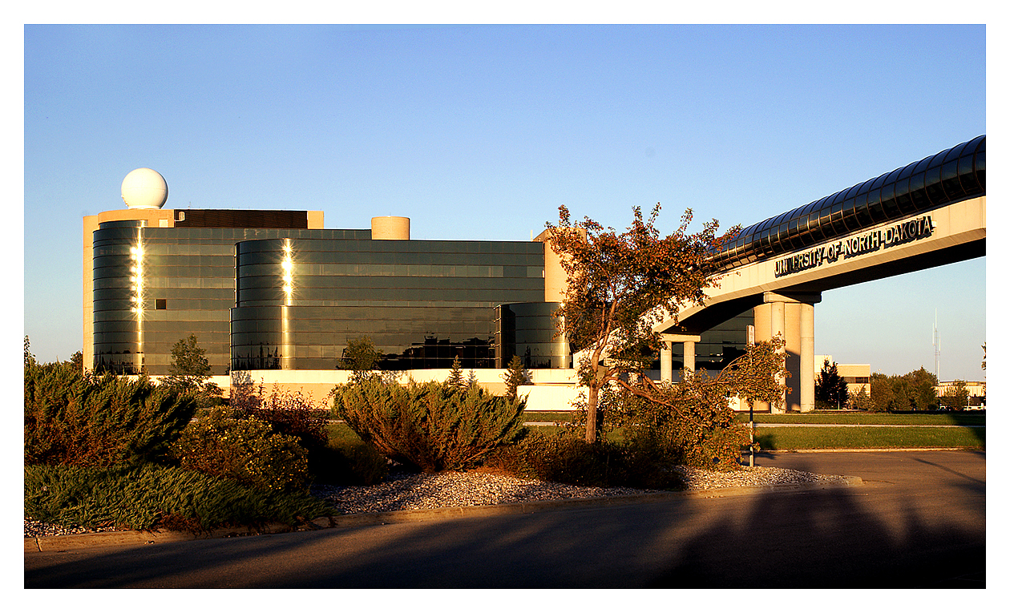



Updated – 18 October 2011
Preface

This manual has been created though a class project to provide users of UND’s polarimetric Doppler weather radar (NorthPol) with a quick reference guide to the options available in the IRIS software that controls the radar and is used for analysis. This document is only a reference guide and if more details are needed on each topic, please see the SIGMET IRIS manuals located in CH422, CH465, 6th floor Clifford Hall, and/or online at http://www.vaisala.com/en/hydrology/offering/weatherradars/Pages/IRIS.aspx. If you need other assistance, please contact the appropriate UND personnel.

Table of Contents

1 Quick Reference 1
2 Overview of the UND Radar (NorthPol) 2
2.1 History 2
2.2 Specifications 2
2.2.1 Antenna Specifications 2
2.2.2 Receiver Specifications 3
2.2.3 Transmitter Specifications 3
2.2.4 Product Types 4
2.3 Workstations and radar network 4
3 IRIS Startup and Shutdown 6
3.1 IRIS Startup 6
3.2 IRIS Shutdown 7
4 Menus 8
4.1 Radar Status 8
4.1.1 Control Section 8
4.1.2 Subsystem Status 8
4.1.3 Antenna/Transmitter Status 8
4.2 TSC Monitor 8
4.2.1 Scheduling a Task to Run 9
4.2.2 Stop Running a Task 9
4.3 TSC Editor 9
4.3.1 ID 9
4.3.2 Task 9
4.3.3 State 9
4.3.4 Scan, Range, and Data 10
4.3.5 Start, Stop, and Repeat 10
4.3.6 EstTime 10
4.3.7 Flags 10
4.3.7.1 Mandatory 10
4.3.7.2 Skip 10
4.3.7.3 Dual Flip 10
4.4 Task Configuration 10
4.4.1 Antenna/Radar Control 11
4.4.2 Processor Configuration 11
4.4.3 Data Corrections 11
4.4.4 Data Quality Thresholding 11
4.4.5 Saving a Task and Exiting 11
4.5 Ingest Summary 11
4.6 Product Scheduler 12
4.6.1 Site Selection 13
4.6.1.1 Display 13
4.6.1.2 Add for 13
4.6.1.3 Site Group 13
4.6.2 Product 14
4.6.3 Data 14
4.6.4 TASK 14
4.6.5 Next-Data-Time 14
4.6.6 Skip 15
4.6.7 Rqst 15
4.6.8 Status 15
4.6.9 Runs 15
4.7 Product Configuration 16
4.7.1 Task Summary 16
4.7.2 Map Projection 16
4.7.3 Product Parameters 16
4.7.3.1 Data Display 16
4.7.3.2 Max Range 17
4.7.3.3 Elevation Angle 17
4.7.3.4 Clip Range 17
4.7.3.5 Clip Height 17
4.7.3.6 Z-R Relationship 17
4.7.3.7 XY Smoother 18
4.7.4 Display Parameters 18
4.8 Message Summary 18
4.9 Product Output 19
4.10 Archive Menu 20
4.11 Overlay Menu 20
5 Quick Look Window 21
5.1 Analysis Tool Bar 22
5.1.1 File Button 22
5.1.2 View Button 22
5.1.3 Tools On/Off Button 23
5.1.4 Cursor Tool 23
5.1.5 Track/Annotate Tool 23
5.1.6 Animation Tool 24
5.1.7 Slide Show Tool 24
5.1.8 Forecast Tool 25
5.1.9 Cross-Section Tool 25
5.1.10 Display Options Tool 27
5.1.11 Products Option Tool 27
5.1.12 Mode Button and Help 27
5.2 Legend Area 28
5.2.1 Product Selection Tool Bar 28
5.2.1.1 Selecting Radar Sites Tool 28
5.2.1.2 Product Selection Tool 28
5.2.1.3 Live Action Tool 28
5.2.2 Time Selection Tool 29
5.2.3 Informational Display 29
5.2.4 Color Bar Legend Tool 30
5.3 Product Display 30
6 Radar Log 31
7 Troubleshooting 33
7.1 Installation Errors 33
7.2 Other Errors 33
8 Common Scenario Procedures 35
8.1 Setting Up Data Archival for a New TASK 35
8.2 Pushing Data/Products from Radar2 to Display Computers 35
8.3 Mounting the Archival Storage Arrays 36
8.4 Re-Ingesting Data When Products are No Longer Available 36
8.5 Ingest archived data to create products 37
9 User Manuals 39
9.1 Contents of User Manuals 39
9.1.1 Chapters 40
9.1.2 Appendices 41
9.1.3 Index 42
9.1.4 Figures and Tables 42
9.2 Updated Manuals 42
10 Acknowledgements 43

Table of Figures

Figure 1. Diagram of UND’s radar computer network. 5
Figure 2. Label bar on xterm window. 6
Figure 3. Sample error message. 6
Figure 4. IRIS Client at startup. 7
Figure 5. IRIS Client with connected workstation identified. 7
Figure 6. Ingest Summary menu screenshot. 12
Figure 7. Product Scheduler menu screenshot. 13
Figure 8. Radar site selection options. 14
Figure 9. Product scheduler command menu. 14
Figure 10. Next-Date-Time menu. 15
Figure 11. Product generation request field menu. 15
Figure 12. Message Summary menu screenshot. 19
Figure 13. Example image of a Quick Look window. 21
Figure 14. Quick Look window section descriptions. 22
Figure 15. Track/Annotate Tool Window. 24
Figure 16. XSECT (Cross-Section) Window. 26
Figure 17. Cross-Section control tools. 26
Figure 18. Display Option Tool Window. 27
Figure 19. Live Action Tool Window. 29
Figure 20. Excerpt from a radar log from the CRYSTAL FACE experiment in July of 2002 in Florida. 31
Figure 21. IRIS Client. 39
Figure 22. Part of the user manual Table of Contents. 40

Table of Tables

Table 1. Antenna specifications of the UND radar. 3
Table 2. Receiver specifications of the UND radar. 3
Table 3. Transmitter specifications of the UND radar. 4
Table 4. Product types of the UND radar. 4
Table 5. Data display parameters. 17
Table 6. Data ranges and units. 18

Quick Reference
A. Log in
-User Name: operator
-Password:

B. In a terminal window, start IRIS by typing siris.

C. After iris is started, type iris in the terminal window to start the iris client (menu bar).

D. Connect to Radar1 workstation from IRIS Client. (Only Radar1 can operate the radar)

E. In IRIS Client, left click Menus, left click Task Scheduler.

F. Select a Task by right clicking on the name of the Task (far left column).

G. Right click in the Command column for the selected Task and left click on GO (Schedule) or GO (ASAP).

H. If the Real Time Display window is not minimized on the desktop, left click Menus on the IRIS Client and select Real Time Display. If the Real Time Display window is minimized on the desktop, double left click on the Real Time Display icon.

I. When finished scanning, in Task Scheduler window, right click in Command column of selected Task and left click STOP (When Done).

J. To view auto-generated Products, on desktop, double left click WINDOW icon.

K. Left click on the SITE button in the upper right corner of the quick look window.

L. Left click on UND.

M. Left click Product Selection button below SITE button in the upper right corner of the quick look window.

N. Select appropriate Product to match your scan.

O. View Product at your pleasure.

P. To exit IRIS, type qiris in a terminal window.

Overview of the UND Radar (NorthPol)

History
The University of North Dakota Polarimetric Doppler Weather Radar (NorthPol) is a 5 cm wavelength (C-band) radar for weather monitoring in both teaching and research. The radar is unique to the area because it possesses both dual-polarimetric and Doppler capabilities. With polarimetric fields, one may determine particle size and type. One may also estimate the winds with the radial velocity field.

NorthPol was acquired by the Department in 1974 with funds from the National Science Foundation. From 1975 to 1993 it was utilized primarily as a mobile facility. It was deployed in research projects to study weather modification such as Skywater (1975; Utah); HIPLEX (1979-1980: Montana); CCOPE (1981: Montana); WISP (1991: Denver); NDTE (1993: North Dakota), POLCAST (2006, 2008, 2010; UND), SNOwD UNDER (2010), and unmanned aircraft research (2008-present). It also participated in a multi-year FAA-funded study documenting detection of microburst and gust-front hazards near Dallas (1993), Orlando (1991), Kansas City (1989), Huntsville (1986), and Memphis (1985) airports and this helped pave the way for the design and installation of the FAA’s 5 cm Terminal Doppler Weather Radars (TDWR) at airports around the country. In addition to UND, NSF, FAA, and Congressional funds, research with the radar has also been supported by the Department of Defense, NOAA, the Bureau of Reclamation, and the Atmospheric Resource Board. The radar has helped bring in $45+ million in research dollars.

The radar has been upgraded several times since its acquisition. The first upgrade came in the 1982-1983 when a Doppler capability and associated hardware/software was added with Congressional funding acquired by John Odegard. A new, larger 12-ft diameter antenna replaced the older 8-ft antenna resulting in improved data quality in 1987. In January 1993 upgrades were preformed to bring the radar back to research quality and the radar was fixed atop Clifford Hall. The system was upgraded with software and components from SIGMET, Inc. The upgrade included an RVP8 digital receiver and signal processor with dual 14-bit IF digitizer, an RCP8 radar antenna controller with custom connector panel for existing cables, an Interactive Radar Information System (IRIS) radar control, analysis, and display software, and two high speed data PC based LINUX workstations with a massive disk storage device. The new system provided seamless integration of the new technology with the old system.

In January 2004, the radar hardware and software were upgraded to have polarimetric capabilities through a NDEPSCoR grant. SIGMET has developed an Antenna Mounted Receiver (AMR) that allows dual-polarization capability at the fraction of the cost of purchasing a new polarimetric radar. SIGMET integrated the polarimetric radar and software components with the earlier upgrades. The upgrade included modification of UND radar antenna to allow transmitting and receiving of both polarizations simultaneously, installation of antenna mounted receiver, and IRIS software upgrades to support polarimetric variables.

During the summer of 2009 through the winter of 2010, the main radar control computer (radar1) and the main analysis computer (radar2) were replaced with newer, more powerful computers. Reinstallation and configuration of the software was completed in the spring of 2010. These new computers provide more computing power for analysis and operations.

Specifications

Antenna Specifications

Table 1: Antenna specifications of the UND radar.
Antenna
Specification | Value
Reflector Type | Parabolic Dish
Reflector Size | 12 ft., 3.66m
Feed Type | Dual Polarized Horn
Polarization | Horizontal and Vertical
Antenna Gain | 43.75 dB (Manufacturer)
Beamwidth | 0.99˚
Azimuth Limits | None
Azimuth Velocity | 20˚/s
Elevation Limits | -1˚ to 90˚
Elevation Velocity | 10˚/s
Synchro Resolution | 0.1˚
Digital Controller | RCP8 (SIGMET)
Rotation Rate | Max: 24˚/s  Typical: 5 to 20˚/s

Receiver Specifications

Table 2: Receiver specifications of the UND radar.
Receiver
Specification | Value
Receiver Type | Dual, separate horizontal and  vertical channels
IF Frequency | 60 MHz
Digital Receiver | RVP8 and dual IFDs (SIGMET)
Minimum Detectable Signal | -106.5 dB
Radar Constant | 64.5 at 2.0 μs PW
Bandwidth | 0.3 MHz
Noise Figure | 4 dB
A/D Converter | 10 bits
Clutter Suppress | 30 dB, 40 dB
Number Range Gates | 1024
Gate Spacing | 25 m, 50 m, etc.
Zmin @ 50 km | -8.0 dBZ

Transmitter Specifications

Table 3: Transmitter specifications of the UND radar.
Transmitter
Specification | Value
Operating Frequency | 5.6 GHz
Type | Magnetron
Peak Power | 250 kW
Pulse Length | 0.6, 2.0 μs
Pulse Repetition Frequency | 250 – 1200 Hz
Band | C
Wavelength | 5.4 cm

Product Types

Table 4: Product types of the UND radar.
Product Types
Reflectivity | Differential Reflectivity
Corrected Reflectivity | Differential Phase
Total Reflectivity | Specific Differential Phase
Doppler Velocity | HV Correlation
Spectrum Width

Workstations and radar network
The UND radar has several radar workstations located throughout Clifford Hall. The workstations are listed below along with a brief description. A diagram of the radar computer network can be seen in Figure 1.

RADAR1 – The main workstation with control access to the UND radar. It is located on the 6th floor of Clifford Hall.

RADAR2 – This workstation is located in the computer lab on the 4th floor of Clifford Hall and is the main computer used for analysis of radar data.

RADAR3 – This workstation is also located in the computer lab on the 4th floor of Clifford Hall. It has free IRIS display software, but has less analysis capability than Radar2. The free display computers also have limited network capability as they are not allowed to connect to other radar computers on the network.

RADAR4 – Similar to Radar3.

RADAR5 – Similar to Radar3.

RADAR6 – This workstation is located in the office of Chris Theisen and is similar to Radar3 except has the ability to connect to other radar computers on the network.

Rayleigh – Similar to Radar3.

Titan – This workstation is located in the computer lab on the 4th floor of Clifford Hall (CH422). The raw UND radar data is pushed to this computer where it can be displayed using the TITAN software package. IRIS is not installed on this computer.

GRLevelX Windows Machines – Some Windows machines located in the computer lab on 4th floor Clifford Hall have a radar analysis software called GRLevelX installed which can also view UND radar data. These computers do not have IRIS installed.

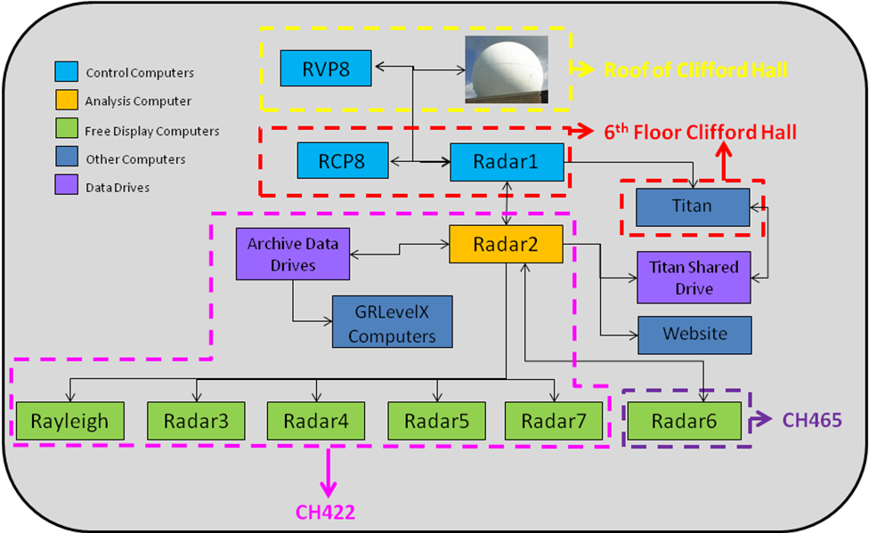
Figure 1: Diagram of UND’s radar computer network.

IRIS Startup and Shutdown

IRIS Startup
Step 1: To login to the workstation type operator at the login prompt, then press Enter.

Step 2: At the password prompt type the instructor-specified password and press Enter.

The computer will now log the user in and bring up the desktop. If IRIS has been started already, there should be two Quick Look Windows that pop up on the screen after login. They can be minimized by clicking the minimize button in the upper right corner of the window. If an xterm (terminal window) also opens upon login then the user can skip to Step 4.

Step 3: To open a terminal window, right click on the desktop and select Open Terminal.

The top of the xterm window should be labeled “operator on [workstation]: /home/operator”, where [workstation] is the particular station being used and the rest of the information is the current working directory similar to what is shown in Figure 2.

Figure 2: Label bar on xterm window.

Step 4: In the xterm window, type siris and press Enter to start an IRIS host.

Note that at this point you might see a message similar to Figure 3 that says “Sorry, IRIS cannot be (re)started while these are active.” This simply means that an IRIS host is already running and the user can move on to Step 5. Another easy way to determine if IRIS is running is to see if you have two Quick Look windows open. IRIS will always automatically open two Quick Look windows on startup.

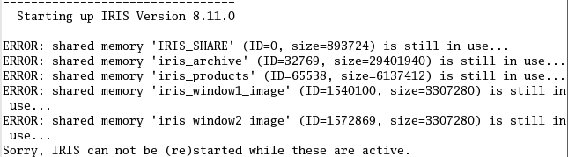
Figure 3: Sample error message.

Step 5: Once IRIS has been started, type iris at the command prompt and press Enter to open the IRIS Client as shown in Figure 4.

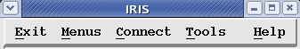
Figure 4: IRIS Client at startup.

Step 6: To connect to the local computer, left click the Connect tab in the IRIS Client and select the appropriate workstation by left clicking. The workstation name is taped for reference to the top of the computer monitor. Note that the top of the IRIS Client is now labeled “OPERATOR: [workstation]” similar to what is shown in Figure 5.

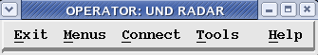
Figure 5: IRIS Client with connected workstation identified.

Step 7: If the user wishes to connect to a different workstation, simply left-click on the Connect tab in the IRIS Client and select the appropriate workstation by left clicking. Although it is not necessary, the user may left click Disconnect under the Connect tab and then choose the desired workstation.

IRIS Shutdown
Step 1: In the IRIS Client, left click the Connect tab and left click disconnect.

Step 2: In the IRIS Client, left click the Exit tab and left click Exit. This will close the IRIS Client.

Step 3: If one needs to completely stop iris, type qiris in the command line. This will complete shut down the IRIS software. This is not advised as some machines need to have IRIS running on them all the time.

Step 4: Close xterm window if desired by left clicking the close button (X) in the top right corner. Alternate method: press Alt + F4.

Step 5: Based on your operating system follow the necessary steps to Logout. This step will log the user out of the workstation and can be omitted if the user wishes to remain logged in.

Menus
This section will provide brief information on the menu options that are available in the IRIS Client. When reading through these menus, there are two terms that are often used that should be defined to help with understanding the purpose behind those selected menus. The words “TASK” and “PRODUCT” are often used in descriptions throughout this document. The work “TASK” refers to the scan strategy of the radar. In other words, the “TASK” is the commands that you tell the radar on how to run to collect data and can be compared to the VCP mode for the NEXRAD radars. A “PRODUCT” is the result of analysis using data collected by a “TASK” (i.e. Rain fall accumulations, PPI and CAPPI displays, etc.). Please keep in mind these definitions when reading through these sections.

Radar Status
This section displays the status of the radar. Although this option is available for each IRIS machine, it does not show you the proper information on NorthPol unless you are connected to Radar1. In order to access this menu, in the IRIS Client, left click Menus and left click Radar Status. If an error occurs that says, “sorry, not connected to an IRIS service”, left click OK and then left click Connect from the IRIS Client. In the drop down box select radar1. It should be labeled on the front, top of the monitor as was shown in Figure 5. A pop up box labeled “radar1 Radar status: DEFAULT” should appear. There are three main sections of the radar status menu: Control Section, Subsystem Status, and Antenna/Transmitter Status.

Control Section
This section enables the user to change a variety of radar control options. By clicking on the button next to the parameter you wish to change a drop down box will pop up with the appropriate options. It should also be known that the buttons that appear to have another button in the middle simply toggle the option on and off.

During normal operations, this menu is only an informational tool as you should not have to use any of the control functions from this section.

Subsystem Status
This section displays the status of the network and equipment including the Radar Control Processor (RCP) and Doppler Signal Processor (DSP). The section is only used to display errors and to confirm proper operation. No settings can be changed here.

Antenna/Transmitter Status
This section displays the status of the antenna location and speed along with the status of the transmitter. No settings can be changed here. However by clicking on the button next to built-in text equipment “BITE” the user can access the BITEX window where options can be set.

TSC Monitor
This menu is the main menu to start and stop radar scanning and is updated only through saving the proper TSC under the TSC Editor menu (section 4.3). You cannot make changes to the operation of these Tasks (either scheduling or changing scan strategies) within this menu option. This menu option is only to start and stop specified Tasks. To open this menu, left click the Menus tab in the IRIS Client and select TSC Monitor. There are eight columns in the TSC Monitor showing information associated with each Task. The ID column only shows an integer number used to identify Tasks within the list. The Task column lists the names of each configured Task. The Command column indicates the status of the specific Task. If the system is not running the Task, the text will read “Idle” in this column. If the Task is currently running, the text will read “Running”. If the Task is scheduled to run, the text will read “Scheduled”, and when the Task is scheduled to complete, the text will read “Run/Finish”.

The Scan column indicates what type of Task is being run. For example, PPIF indicates a full PPI and PPIS indicates a PPI sector. The Start and Stop columns indicate the times when the Task will start and stop. The repeat column indicates how often the Task should be run. The last column, Run Time, indicates the time it takes to complete the Task. This column will not be populated with values until the Task has run at least once.

Scheduling a Task to Run
To schedule a Task to run, select the proper Task by left clicking on the Task name. Right click Idle in the Command column (third column) and select either GO (Schedule) or GO (ASAP). GO (Schedule) will start the radar based on the scheduled entered by the user in the TSC Editor section and indicated by the Start, Stop, and Repeat columns in the TSC Monitor. GO (ASAP) will start the scanning without delay.

Stop Running a Task
To stop a Task from running, select the Task by left clicking on the Task name. Right click Running in the Command column (third column) and select Stop (When Done) or Stop (Right Now). Stop (When Done) indicates that the radar will stop scanning at the end of the specified Task. Stop (Right Now) indicates that the Task will stop when this option is selected without ending the Task. This option should only be selected if it is important that the scan be stopped prior to finishing (i.e. if there is a critical error in the system).

TSC Editor
This menu is used to schedule specific Tasks at specific times. It is used to update the active TSC Monitor (section 4.2) and can be accessed by selecting TSC Editor from the Menus tab in the IRIS Client. A dialog box will open with approximately eleven columns and other options available just below the menu bar. To edit a previously defined TSC, go to File and then Open. From the drop down list, select the TSC you want to edit. The name of the TSC will be shown in the title bar. There are six option sections at the top of the TSC Editor used to adjust parameters in the selected Task from the list in the bottom section of the TSC Editor. There are eleven columns of parameters in the bottom section of the TSC editor.

ID
Shows an integer number used to identify Tasks within the list.

Task
This section is used to see which Tasks are currently in the TSC list. Right clicking on any Task brings up options to manipulate the Task configuration, to remove the Task from the list, or to add a different Task to the list. These same options are listed in the top left section of the TSC Editor.

State
This section displays the status of each scan that is in the TSC list. You cannot start or stop the scan from this section. This status is only informational and is changed through running Tasks within the TSC Monitor (section 4.2).

Scan, Range, and Data
These sections simply display parameters specific to each Task and are changed via the Task Configuration menu option from the IRIS Client.

Start, Stop, and Repeat
These sections are adjusted by highlighting the appropriate Task and using the options above the columns to adjust the times in hours, minutes, and seconds.

The start time indicates the time to start the Task when using the command GO (Schedule) from the Command column in the TSC monitor menu.

The stop time indicates the time to stop the Task when using the command GO (Schedule) from the Command column in the TSC monitor menu.

The repeat time indicates how often the Task should repeat when the State column is set to GO (ASAP) or GO (Schedule).

EstTime
This field shows the estimate time required to run a selected Task.

Flags
This section is adjusted by right clicking on the field and selecting from three options; Mandatory, Skip, and Dual Flip. This option is only used when the system has two or more computers controlling one antenna. It smoothes over any scheduling conflicts between two computers. In the current configuration the flag value is “Mandatory”.

Mandatory
This option sets the priority of the Task high and does not let another Task interrupt the current one running.

Skip
This option sets the priority of the Task low and allows other Tasks to interrupt the current Task running.

Dual Flip
This option does not apply to UND radar. It is used only when operating two different transmitters and receivers.

Task Configuration
This menu allows the user to configure Tasks, which are scan strategies for the radar, and can be accessed through the IRIS Client by left clicking the Menus tab and left clicking Task Configuration. A large pop up window should appear with four main sections; Antenna/Radar Control, Processor Configuration, Data Corrections, and Data Quality Thresh holding. The text box at the top of the window is simply the description of the Task.

For more detailed descriptions on each of these sections, please refer to the SIGMET IRIS manuals.

Antenna/Radar Control
The most important option in this section is the scan mode because it changes the amount of options available for the other parameters in this section. The user can change the options in this section by left clicking in the text box of the option or left clicking on the button next to it. In the azimuth and elevation angles options each angle has to be separated by a space.

Processor Configuration
The user can change the options by left clicking on the button next to the desired field. Some fields, such as Unamb Vel and Unamb Range, will be automatically updated when changes are made to a dependent field (such as PRF and Max Range), however, others will not. When a field is set to an impossible value, the box will turn red. The value in that field must be corrected in order for the Task to properly run.

Data Corrections
This section is used to make corrections to data as it is received using SIGMET’s algorithms. The buttons next to the options toggle them on and off. To gain knowledge of each buttons powers please refer to the SIGMET manuals.

Data Quality Thresholding
This section is used to set the minimum amount for each parameter received by the radar. The options for each parameter can be changed by clicking on the buttons next to the names or sliding the slide bar to select the appropriate value. These options and thresholds are adjusted to offer the user with the desired data collected. The user can select to have none of the incoming data be removed, or have a large portion of it removed to try and mitigate spurious data such as second trip echoes and ground clutter. It is recommended that before adjusting these parameters, refer to SIGMET’s manuals to gain a better understanding for consequences for adjusting each of these thresholds.

Saving a Task and Exiting
The Task configuration is closed by either left clicking on the X in the upper right hand corner or by left clicking File and left clicking Close. The Task is not automatically saved. Therefore, the only way to permanently save a Task is to left click File and left click Save as. Fill in the desired name and left click OK.

Ingest Summary
The Ingest Summary (Fig. 6) menu in the IRIS Client lists ingested data and associated information that can be accessed to create Products and is accessed by left clicking Menus in the IRIS Client and left clicking Ingest Summary. The amount of time that these files are stored will vary depending on the size of the local machines hard disk partition for storing this data and the amount of data collected through time. The raw data is stored in a partition on the hard disk and once the number of files increases past a user defined threshold, the older files will be removed from this partition. This is not deleting the raw file from the storage device, but only removing it from local drive to make room for more incoming data. The data that is removed from the local drive can be re-ingested for analysis through the Archive Menu option in the IRIS Client. The ingest files contain all the data collected from the signal processor each time a TASK runs and are cataloged by their TASK name and by the date of their collection. The Ingest Summary provides a summary of information about the data collected through various Tasks.

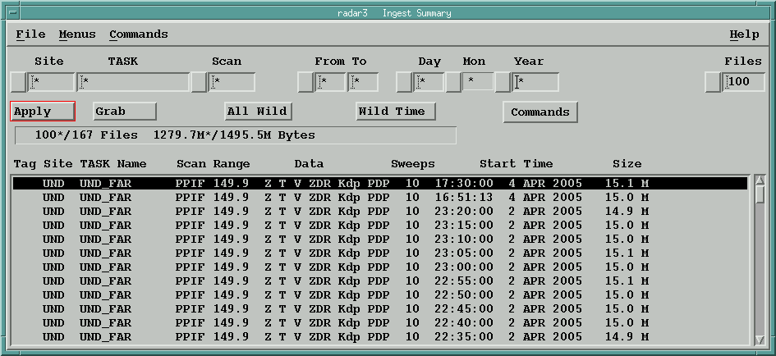
Figure 6: Ingest Summary menu.

Available options within the Ingest Summary menu are that you can either Keep, Delete, Un-tag or select the ingest file as a Clutter scan. To access these options, simply right click anywhere on the ingest file of your choice. Refer to the SIGMET manuals for detailed descriptions on these options.

Product Scheduler
As a refresher, a Product is the analysis of data collected by the radar through a Task and displayed to the user. Creation of Products is controlled by the Product Scheduler which is unique to each IRIS machine on the network. This menu tells the local IRIS system what Products to generate and when to generate Products for fully automatic or manual operations. It can be found by going to the IRIS Client and clicking on Menus and selecting Product Scheduler. Figure 7 is an example image of a Product Scheduler menu. A user can customize the list of Products being generated and save them with different names. One should get in the habit of checking to make sure the proper scheduler is opened prior to making changes. This can be done by checking the title bar as the name of the Product list will be located there. One can also click on File and then Open to get a list of available Product scheduler lists that have been created on the local machine.

The types of Products that can be generated are dependent on the machine license. The free display computers, and radar1, have limited Product generation capabilities. Radar2 is the only machine on the network that has a full license to generate all the Products UND has purchased. As these Products can only be generated on radar2, they can still be viewed on other machines as long as radar2 sends the generated Product to that selected machine via the Product Output menu discussed later on in this manual.

To get specifics about each different Product, please see the SIGMET manuals.
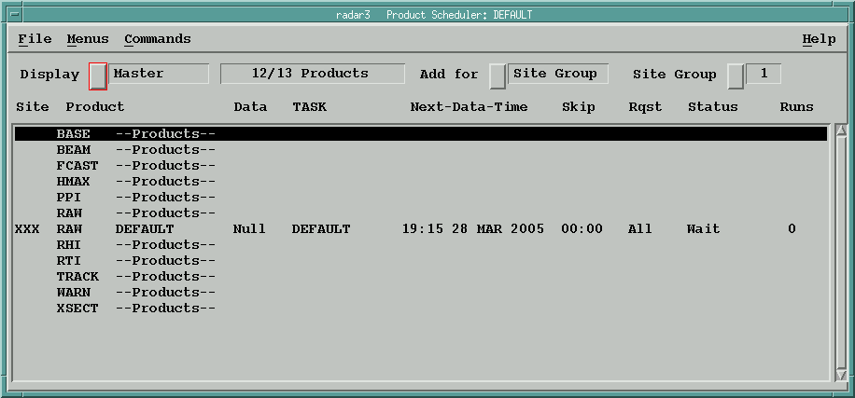
Figure 7: Product scheduler menu.

Site Selection
This option allows the operator to specify what Products are created from each radar in the system (in a multi radar configuration or as in playback mode) when data is made available by that radar. Options are available at the top of the Product Scheduler to sort the list of Products being generated. The options include Display, Add for, and Site Group.

Display
Left clicking on this button will reveal several options: All Sites, Master, Site Group, and various single sites. The All Sites option will show the Product Schedule for all radars on the system. The Master option consists of one entry for every Product that was scheduled. For multiple radar Products, the most recent radar that was run will be shown. The Site Group option shows the Products that are configured for a certain group of radars. Selecting one of the single radars will display Products that correspond to that radar only.

Add for
This button has several options: All Sites, Site Group and single groups. For the All Sites option, when a Product is scheduled, it will be added for all the radars. The Site Group option will add the scheduled Product to the radars defined in the group. Selecting a single radar will schedule a Product for only that particular radar on the system.

Site Group
This button allows the user to see the local radar site, along with any other radar sites that are stored in the system. NorthPol’s identifier is UND. By left clicking the button, a pop-up will appear similar to Figure 8. The asterisk (*) indicates a site where a Product is scheduled. If you right click on the entry, you can add or remove the asterisk tag.

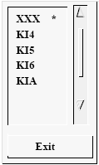
Figure 8: Radar site selection options.

Product
This column shows the different Products available for each machine to generate along with all the Products already configured and scheduled. Products that have been configured but not yet scheduled are not included in the list until they are added by the user. First, select a Product type (at the top of the list of already configured Products for that Product type and as seen in Figure 7 for the Raw Product) from the list by left clicking on it. By right clicking the selected Product, a pop-up will appear similar to Figure 9.

There are three different commands available. The Add command allows the user to add a Product to the schedule. The Remove command removes the Product from the list for the displayed site. The Edit command will open the Product Configuration for the selected Product.

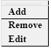
Figure 9: Product scheduler command menu.

Data
This column shows what type of data the Product is generated from, such as dBZ and V for reflectivity and velocity, respectively.

TASK
This column displays the Task name in which this data was collected.

Next-Data-Time

This column displays the time for which the Task will be processed. By right clicking the Next-Data-Time field, the following pop up will be displayed, allowing the user to change the time to look for raw data files to generate the associated Product. The buttons are as follows: the HH refers to hours, MM refers to minutes, DD refers to days, MO refers to month and YY refers to year. The + increases while the – decreases each of the fields. Click OK to allow the changes to be made to the Product’s scheduled time.

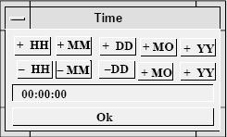
Figure 10: Next-Data-Time field menu.

Skip

This column allows the user to make sure that not every Task is processed by the Product Generator. This is ideal when not much meteorological activity is occurring. It breaks the day into equal intervals starting at midnight. The default value is “00:00”, which means that the Product will be generated every time a new associated Task completes. Right clicking the value in this field will display a pop up allowing the user to set a skip time.

Rqst

This option stands for Request. By right clicking this column, a pop-up will come up similar to Figure 11. The All option schedules the creation of the selected Product for all future occurrences of the associated Task that remain in the system (identified through the Ingest Summary). The Next option only creates a Product for the next occurrence of the associated Task. The Stop option stops the creation of the selected Product.

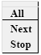
Figure 11: Product generation request field menu.

Status

This column is only informational and displays the current status for each of the Products. The possible informational texts that would appear in this column are Running and Wait. The Running option shows that Products are being generated. The Wait option indicates that Products are waiting for either the associated Task to run or for its turn to run pending the completion of other Products. The Wait status is also shown if the Product is not scheduled to run.

Runs

This column is only informational as it displays the number of times the Product has been run. It goes from 0 to 999. Once it exceeds 999, it starts over at 0. If the user stops a Product generation, the counter is not reset. It is only reset when you delete a Product and then reload it into the scheduler. If you load a new schedule, all the counters will be reset.

Product Configuration
The user can configure specific Products that aid in analysis of the radar data. This configuration is done in the Product Configuration menu accessible through the IRIS Client. The first, and important, step in configuring a Product is to select the Product type from the Type menu in the Product Configuration menu bar. Changing types will change the available options to configure.

The Product Configuration menu options are different for each Product type. The following description is based on what is needed for generation of PPI Products. Some of these options may apply to other Product types and are still useful in understanding the Product Configuration procedures. For detailed descriptions on configuring the different Product types, please see the SIGMET manuals.

The Product Configuration menu is broken up into four main components for a PPI Product creation; Task Summary, Map Projections, Product Parameters, and Display Parameters.

Task Summary
The Task Summary allows the user to select the Task used which will provide the data to creation of the configured Product. The user can select the Task from a drop down list of available Tasks by clicking on the button to the right of “Task Name”. Once a Task is selected, the other informational boxes within the Task Summary will automatically fill with the Task information.

Map Projection
This option allows the user to change how the data are projected to the map. Default value is using the Azimuth Equidistant (AED) projection. If another projection is desired, the user can specify this during Product configuration. The map projections to choose from include: Azimuth Equidistant, Mecator, Polar Stereographic, Universal Transverse Mercator, Perspective, Equidistant Cylinder, Gnomonic, and Gauss Conformal.

Product Parameters
This section allows the user to adjust certain variables that are used in Product creation.

Data Display
The Data:Display option allows the user to select which type of radar variable to display. Left click the button next to Data:Display and select the desired variable. Table 5 shows the options that are provided in the Data:Display list and their definitions.

Table 5: Data display parameters. Asterisked parameters indicate those which are not available with NorthPol.
Type | Definition
dBT | Total Reflectivity
dBT:R | Rain Rate using dBT
dBZ | Reflectivity after data thresholding
dBZ:R | Rain Rate using dBZ
dBZc | Corrected Reflectivity using SIGMET algorithms
dBZc:R | Rain Rate using dBZc
V | Radial Velocity
Vc | Corrected Radial Velocity using SIGMET algorithms
W | Spectral Width
SQI | Similar to Signal-to-Noise Ratio (SNR)
User | ?
HClass | Hydrometeor Classification*
ZDR | Differential Reflectivity
ZDRc | Corrected Differential Reflectivity using SIGMET algorithms
Kdp | Specific Differential Phase
Kdp:R | Rain Rate using Kdp
PhiDP | Differential Phase
RhoHV | Correlation Coefficient
LDRH | Horizontal Linear Depolarization Ratio*
LDRV | Vertical Linear Depolarization Ratio*
PhiH | Horizontal Differential Phase*
PhiV | Vertical Differential Phase*
RhoH | Horizontal Correlation Coefficient*
RhoV | Vertical Correlation Coefficient*

Max Range
This option will allow the user to specify the maximum range desired for creating the Product. This range generally is set to the unambiguous range of the Task, but can be set to any range the user desires.

Elevation Angle
The asterisk indicates the software will create Products at every elevation within the volume scan. This can be changed to plot specific elevations only. The values that should be placed in this option should be in decimal degrees and associated with an elevation angle listed in the scan strategy of the selected Task.

Clip Range
This option can truncate the range on the Product creation. Rarely used, this option helps in some optional Product creation. The zero entered as default disables this parameter.

Clip Height
Similar to Clip Range, but the variable being truncated is height.

Z-R Relationship
Allows the user to specify a specific Z-R relationship.

XY Smoother
Allows the user to smooth out data if the resolution has been disfigured or pixels are missing. This option allows for a smoother picture to be produced.

Display Parameters
This section shows how the Product will appear in the display. In this section, the Display Units, the Color Scale, the number of Levels, and the Resolution can be adjusted. A list of the different Display Units parameters and their respective resolution and units available are shown below:

Table 6: Data ranges and units.
Type | Range/Units
dBZ | –32 to 96 dB mm6/m3
dBZt | –32 to 96 dB mm6/m3
Rain | 0 to 1000 mm
Velocity | ±Vu m/s
Width | 0 to Vu m/s
ZDR | ±8 dB
Tops | 0 to 25.5 km or height configured in Setup
VIL | 0 to 65.0 mm
Wind | Configured in Setup
Shear | ± 25 m/s/km

Once finished with configuring your Product, left click File and left click SaveAs to save the configuration. Make sure to name the Product differently than other currently configured Products. If another Product is already configured to perform the same analysis on the same Task, use the previously configured Product. Do not change previously configured Products unless specifically directed.

Message Summary
When an error occurs while running IRIS, which it occasionally does, the Message Summary menu is a good place to check to see what went wrong. It can be accessed from the IRIS Client by left clicking Menus and left clicking Message Summary. This menu lists the messages and warnings that have been issued by IRIS. However, when first entering the Message Summary menu, the fields in the Message Summary are left blank. To display information on a specific generated message, left click to highlight a message in the list and IRIS will then fill in the summary information. The Message Summary includes information about the cause of the error and the code module that handled the error. What is known as the Message List contains a list of the error messages in chronological order. In addition to all this information, an error log is kept as a disk file in the event that there is a power failure. The menu also lists the mistakes that you may have made while configuring the system. The Message Summary allows for easy access to the errors that have occurred with IRIS. This aids in debugging the system and is helpful to keep the radar running at a healthy status. However, if a software error is recorded, it must be reported to SIGMET.

Within the message summary, information such as the date of the error, how many times the specific error has occurred, and a summary message of the error is presented. An example of the message summary menu and possible errors is shown in Figure 12.

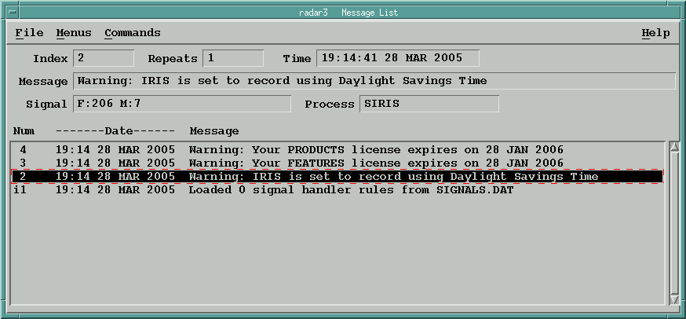
Figure 12: Message Summary menu.

The various fields of the Message Summary all hold information for the particular, highlighted message. The Index portion of the Message Summary assigns a number to every message in the order at which they occurred. Since there are no duplicated messages, the Index field shows the number of the latest occurrence for that message. The Repeats field shows the number of times the message has occurred, while the Time field shows the time of the most recent occurrence of the message. The Message field contains the same message that is displayed in the Message List. The Signal field reports the name of the signal generated (or error condition code) that is handled by IRIS and must be reported for a software error when contacting SIGMET. The Process field shows the name of the code module that trapped and processed the error. This information is also important when contacting SIGMET with software errors. In the Message List, the Date lists the date and time of the most recent occurrence while the Message field contains the message text.

To clear the messages in the Message Summary, restart IRIS. This can be done by typing qiris followed by siris in an xterm window. However, make sure to correct the source of the error otherwise the same message will continue to appear.

Product Output
This menu option is the hardest menu to learn within the IRIS software and should not be attempted to modify unless directed by someone with knowledge of the operation of this menu.

To open this menu, left click Menus located on the IRIS Client and left click on Product Output. If the computer is already connected, the title bar that normally labeled IRIS will instead state “Operator: UND Radar” or “Operator: UND Analysis”. This menu controls where all the data is sent to on within the radar network. This includes sending the data to the archives to record all raw data from the radar, sending specific data to selected display machines, sending information to the website, and even to printers or tape drives for additional storage. It is a convenient way to stop all output to all users if a problem develops.

If a computer is configured to view/connect with other radar computers on the network, it is has the ability to pass selected data back and forth as well. Please refer to the SIGMET manuals to gain further understanding on this menu option.

Archive Menu
The Archive Menu is available through the IRIS Client by left clicking on Menus and selecting Archive Menu. This menu is for accessing all the archived data and controlling when new data is written to the archives. Through this menu, the user can examine historical data by re-ingesting the data. Before any data can be written to an archive storage device, the device must be mounted and inventory taken of all the data already on the device. This process must be done every time IRIS is restarted on the local machine. Currently, the only machine on the radar network that utilizes this menu option is radar2 as it is the source for all archived data. Once the data drives have been mounted and inventoried, the Archive Menu must be set to Record in order for new data to be written to the storage unit.

In order to re-ingest historical data, the drive needs to be set in Retrieve mode. This will allow the user to re-ingest the data for creating Products. After retrieval of the data, the Archive Menu must be set back to Record for the selected drive so not to miss recording incoming radar data.

More detail on operation of this menu option can be found in the SIGMET manuals.

Overlay Menu
To open this menu, left click Menus in the IRIS Client and left click on Overlay Menu. This menu option is used to select an overlay file to be associated with a select radar. This overlay file contains latitude and longitude information on items such as roads, towns, terrain, etc. that can be displayed on the Products and real time display. These overlay files must be hand programmed to provide this information. The help option provides information on the Overlay menu and assigning an overlay to a radar site.

Quick Look Window
The Quick Look Window (QLW) is designed to view and analyze IRIS Products. Upon starting the IRIS software two QLWs should appear (these windows may take some time, approximately a couple minutes, to pop up after start of IRIS). IRIS windows can also be displayed on X-Windows software with MS Windows. The QLW can only be minimized and cannot be closed. Figure 13 shows an example of a QLW.

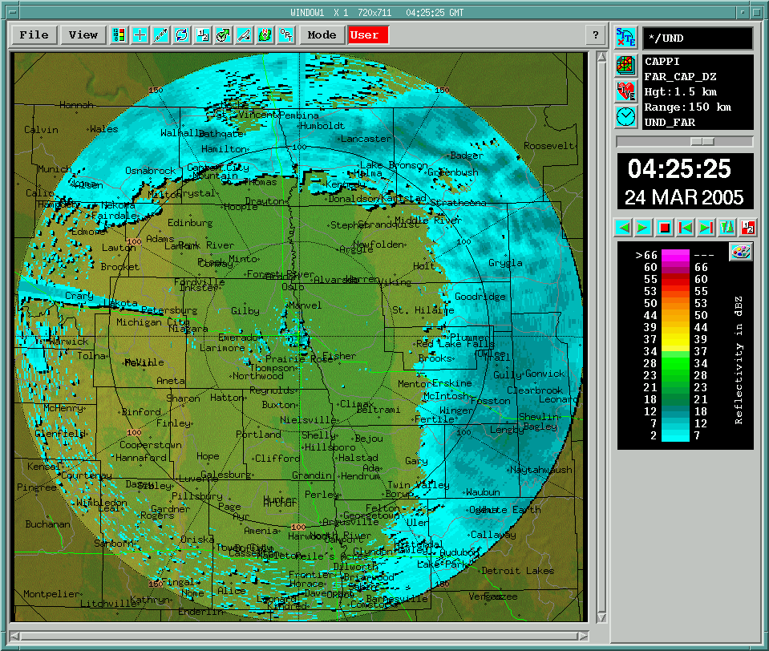
Figure 13: Example image of a Quick Look window.

The general layout of the window is a PPI (Plan Position Indicator) display. The top of the window shows a bar which contains the title and other information. The first part of the title bar will say either “WINDOW1” or “WINDOW2”, depending on which of the two windows are being used. The next part depicts the current zoom setting of the QLW. For example, “X 1” means that the QLW is not zoomed in at all, whereas “X 2” means that the screen is zoomed in by a power of 2. The next part of the bar, “480x480” shows the pixel resolution of the QLW. The last part of the title bar shows the time that the image was taken and is only available if a Product is being displayed.

The QLW is broken up into six main sections which include: the Analysis Tool Bar, Legend, Time Selection Tool, Product Selection Tool Bar, Informational Display, and the Product display section. These sections are identified in Figure 14.

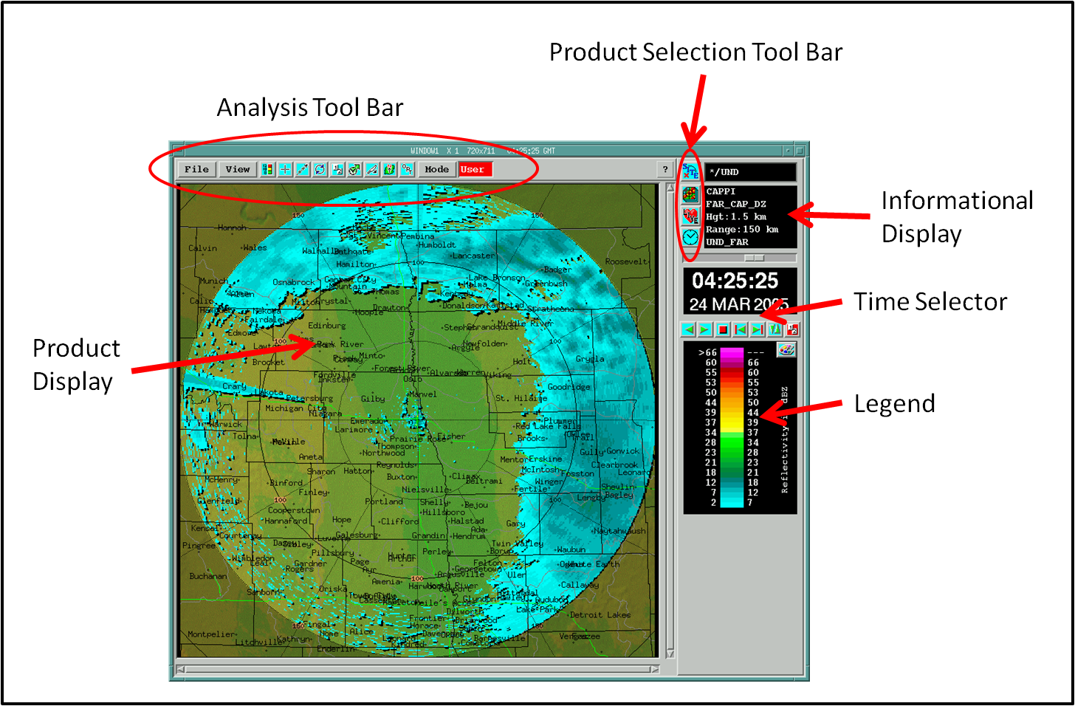
Figure 14: Quick Look window section descriptions.

Analysis Tool Bar
The analysis tool bar is a collection of analysis tools located directly beneath the title bar of the QLW. The tools area includes the following icons: file menu, view menu, tools on/off button, cursor tool, track/annotate tool, animation tool, slide show tool, forecast tool, cross-section tool, display options tool, the Product output options tool, mode menu, status box, and “?” button. These tools are to aid in the analysis of the data presented in the Product.

File Button
The File button in the upper left hand corner of the display window contains options for printing, setting privileges, and exporting displays. The print tool has options for printing to a printer, printing to a file, and print setup tool that allows a user to configure a printer. The export tool sends information to a disk on a local computer or a remote computer. Also, the export tool allows a user to send information in an assortment of formats, which are TIF, BMP, Post Script, and GIF formats.

View Button
The View button contains options where the users can zoom and choose the size of the window of the display. The zoom level can be set and then the scroll bars can then be used to position the zoomed area in an area of interest. Note that for the size it is usually preferred to have a square display chosen over a rectangular display. The reason that a square display is usually preferred over a rectangular display is because most Products are made for a square display.

Tools On/Off Button
Clicking on the on/off button will make the tools and legend disappear. The off position displays no legend and tool bar. To make the tools reappear, right click anywhere within the QLW window and select “tool on” with a left or right click.

Cursor Tool
The cursor tool is a tool that can be used to click anywhere on the map and data will show up in a window for the particular location clicked. The data included in the window is information on latitude, longitude, height, range, slant, bearing, and elevation of the spot. The height shows the height above the curved surface of the earth according to the cursor position. The range shows the distance along the curved surface of the earth to the object from the radar. The slant range gives the distance along the radar beam. The bearing is a measure in degrees from north of the object with respect to the radar. The elevation is a measure of the elevation from the radar to the object or cursor point.

The location that the cursor tool uses to calculate range and bearing can be changed. The default, and mostly used option, is using the radar as the home location. On the right side of the Cursor Tool GUI is the option to change the home location if you want the range and bearing calculated from a different location. This is often the case when trying to direct aircraft to specific locations during weather modification or weather sampling missions with the UND Citation research aircraft.

Track/Annotate Tool
The track/annotate tool has lots of features that forecasters can use. The track tool can determine the track of a storm and when it is going to arrive and a certain location. The annotate tool can also add annotation text to the display in various sizes and colors. The annotate tool can add icons of various colors and types. The main window for the track/annotate tool is shown below in Figure 15. The left side of the window contains the “Action” of the cursor. The selection of the forecast target point needs to be also selected on the left side. Before starting a new track, the user must first clear all previous points by clicking the Delete All Points button on the left side center. There is also an option on the left side to change your home position similar to that of the cursor tool. The right side shows the forecast and track information. There is a slider bar that is used to change the time of the forecast.

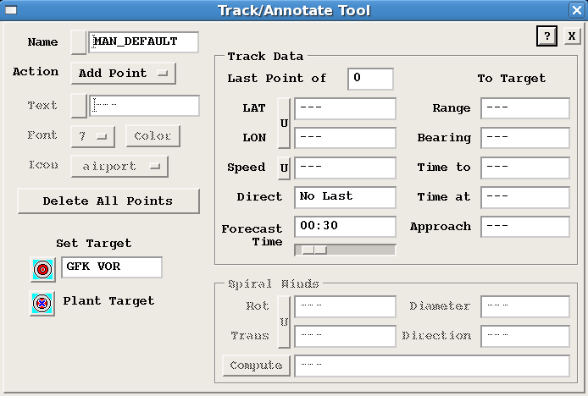
Figure 15: Track/Annotate Tool Window.

Animation Tool
The animation tool is a good way to look at all of the radar echoes as they progress in time. The loop window operates similar to a DVD player. Inside the window is the flush button which when clicked gets rid of the frames and all the frames are forced to reload. The reloaded frames will include any changes that have been made since the last flush. The grab time button selects the time that the loop will end. This is done by looking through the images or frames and clicking the grab time button for the one that needs to be last.

Slide Show Tool
The slide show tool is very similar to the loop tool in that it helps ease the observation of different frames. One feature that is different with the slide show tool is that it is able to observe the different Products of the radar while going through the slide show, whereas the animation tool can only observe one Product at a time. The slide show can be initiated using two different methods. The first and easiest way is to click on the slide show button on the legend side of the QLW. The second way is click on the slide show button in the tools area of the QLW and then click on the slide show button once again in the slide show window. The next part in the window shows the “number of slides in show”. The maximum number of slides that can be in a slide show is 16. Below this are various fields relating to the different options that a slide show can have. For the Product Type and Name just type the Product name that is needed. Once the Product has been saved on the disk, it will then be presented in the slide show window. The time lag specifies the Product version that wants to be displayed. Thus, 0 would tell the computer to work with the current version of the Product, 1 would tell the computer to work with a previous version of the Product, 2 would tell the computer to work with a version of the Product that is two versions old, and this can continue until 15 is reached. The dwell time window allows a user to input a time for each slide to be displayed.

Forecast Tool
The forecast tool takes existing Products that have been created and forecasts Products into the future. This is done by assuming that the wind will not change in the future. Users of the forecast tool are required to input a speed and direction. The forecast tool takes all of the data bins and shifts them using the input of wind speed and direction to a selected time in the near future.

Cross-Section Tool
The cross-section (XSECT) tool is used to give an idea of the internal workings of a particular storm or series of storms. The XSECT window is the window that shows the results of the cross section (Fig. 16). The options to control features of the cross-section are done using the cross-section tools similar to that shown in Figure 17.

The cross-section tool is good at showing the echo heights of the storm and also the storm structure. The XSECT window also shows the area below the lowest elevation angle of the radar. The reason that the cross-section doesn’t contain any data in this region is because in a standard atmosphere, the surface of the Earth falls out from underneath the ray faster than the ray bends back towards the Earth. This produces an increase in ray height with range from the radar. The cross-section line can be seen on the display of the main Product (i.e. PPI, CAPPI, etc.) as a white line with two “+” markings at the end of the line. Also shown along with the line is a little white arrow pointing at the line. This is displayed to indicate which direction the user would be looking at the cross-section.

The cross-section line can be moved by click and dragging the line anywhere within the Products display. If the user desires to keep one end of the cross-section stationary while moving the other end, to change cross-section length and/or angle, click on the “+” and drag it to a new location. The XSECT tool (Fig. 17) can also be used to fine tune most of the aspects of the cross-section. For example the height of the cross-section can be changed to the preferred height by clicking inside the box. Also note that certain Products cannot be used for cross-sections (i.e. RAIN1 and RAINN). This cross-section tool can only be used on Products with a third dimension associated with them in the data. Also, the cross-section can only be taken if the raw data is still ingested into the local system. You may get an error stating you need to re-ingest the data for that time period if data has been pushed out of local storage.

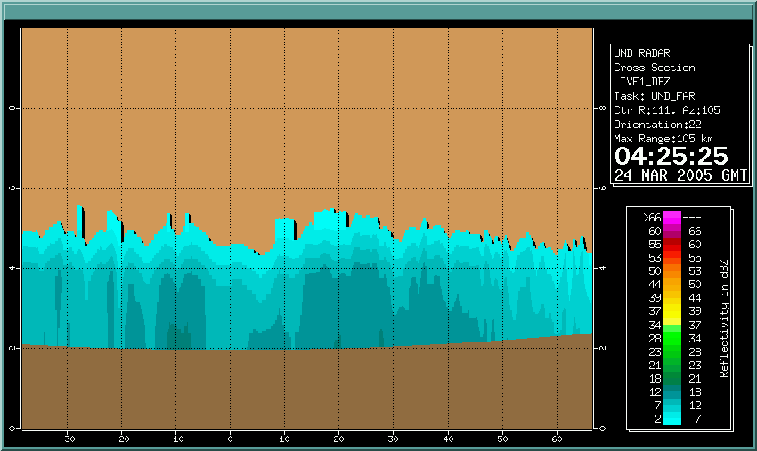
Figure 16: XSECT (Cross-Section) Window.

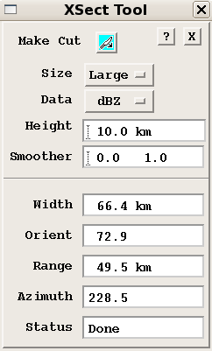
Figure 17: Cross-Section control tools.

Display Options Tool
The display options tool brings up a window which gives options for changing how things are displayed within the QLW. These options include changing the range rings, overlaying different Products, echo tracks, warning centroids, shadows, and geographic overlays. Figure 18 shows the display options window. For more detail about these options, please see the SIGMET manuals.

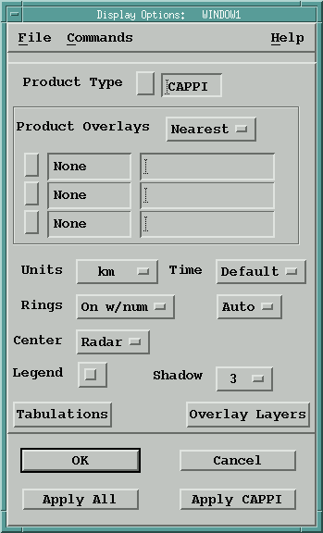
Figure 18: Display Option Tool Window.

Products Option Tool
The Product Options Tool is available for several Products to provide additional options to the user for the output of Products. If one of these Products is on the screen, then the Product Options Tool is sensitized. This means that the user will be able to change some of the options for that particular Product through this icon. For some Products the user can do a File -> Save so that the configuration for the user’s particular window is saved.

Mode Button and Help
The Mode button can be used to change the status of the image displayed in the QLW. The Mode button can be used to change to auto mode, user mode, slide mode, or loop mode. Auto mode indicates that Product Output Menu is automatically updating the display with new images. User mode indicates that the user is choosing which images are displayed in the window. Slide mode indicates that the images being displayed in the window are being controlled by the slide show tool. Loop mode indicates that the images being displayed in the window are being controlled by the loop/animation tool. Also, the green in the status box indicates that the images are automatically being updated by the IRIS software, and the red in the status box indicates that the images are not automatically being updated by the IRIS software. Red in the status box doesn’t mean that something is wrong with the radar but means most time that QLW is being used by a user.

Also the “?” button in the upper right hand portion of the tools bar brings up the Quick Look Window chapter in the SIGMET manual and can be used for further learning of the Quick Look Window’s (QLW) features and options.

Legend Area
The next part is the legend area which is in the right portion of the Quick Look Window. The legend area includes the following icons: Product Selection Tool Bar, Time Selection Tool, Informational Display, and the Color Scale Legend Tool.

Product Selection Tool Bar
The next part is the legend area which is in the right portion of the Quick Look Window. The legend area includes the following icons: the selecting radar sites tool, Products selection tool, live action tool, time selection tool, displaying information tool, and the color scale legend tool.

Selecting Radar Sites Tool
The Selecting Radar Sites Tool is fairly self explanatory and is used to the select the site of the Product image being looked at. The radar site is usual pre-selected so the user doesn’t usually have to worry about this tool.

Product Selection Tool
The Product Selection Tool is used to select a Product type to be used and then select a Product name to be used. This is done by first clicking on the icon that is directly below the site icon. Upon clicking the Product Selection Tool icon, a small window will appear from which a particular Product type can be chosen. After choosing the proper Product type, a Product name can then be selected from a list appearing below the Product type. One thing to note is that only Products that are on the IRIS system for the chosen site will appear in the list inside of the Product Display window.

Live Action Tool
The live action tool is used by the user to interactively generate, configure, and display various IRIS Products. If one of these selected Products are on the display, then the live action tool becomes active. An example of the Live Action Tool is shown in Figure 19. The Live Action Tool allows for constant updating of a particular IRIS Product by regenerating the Product. This feature requires the Product to have access to the raw data file that should be ingested into the local system. The system must be licensed for the Live Action Tool bar to be available.

In the Live Action Tool, users can modify the product settings on the fly such as the cross-section line position, CAPPI height, PPI elevation angle, and smoothing value to see continuous “live” updates on the display. These updates to the display typically show at more than 10 frames per second making the use of the slider bar more efficient to quickly scan through the raw data. The user can quickly examine the vertical storm structure by scanning up and down in elevation and/or CAPPI heights. The user can also select from data types displayed (Z, T, V, W) through this tool.
Figure 19: Live Action Tool Window.

Time Selection Tool
The Time Selection Tool is used to select the time that the user wants displayed in the QLW. The icon should be able to be easily found because it resembles a clock. When the icon is found click on it and a window will appear with a list of all the times that can be chosen. Then select the preferred time from the list. Below the time selection tool is a time slider, which can be drug back and forth by the mouse to show the different times. Below the time and date of the radar image are the loop control buttons, which operate similar to the button on a DVD player. These three options are given to the user to choose from for selecting the appropriate time for the desired Product.

Informational Display
The black boxes on the top right corner of the QLW with text are informational displays. These areas display important information regarding the generation of that selected Product. The box to the right of the Product Selection Tool Bar indicates the name of the Product, the name of the Task used to create the Product, and other information on the Product. The section above the Time Selection Tool slider bar contains other useful information such as, image resolution, PRF used to obtain data, maximum and minimum values within the image, and locations of those maximum and minimum values.

Color Bar Legend Tool
Just to the right of the color bar is the Color Bar Legend Tool. This tool allows the user to configure how the color bar is displayed/configured. This can be used to change the color bar to a gray scale representation of the data, or even to change the scale of the color bar.

Product Display
This area displays the Product that was created.

Radar Log
A radar log details information about what happened with the radar at a specific date/time and for a specific radar operator (e.g., see Fig 20). (It is different from the error log which is tracked automatically by IRIS.) Every time the radar is used, the radar log should be filled out so that the next person using the radar knows what has happened in the past. Things to include in the radar log are location of echo, strength of echo, problems with the radar and when the radar has been started/stopped, and the initials of the radar operator (who is usually the person filling out the log). Atmospheric conditions observed outside should also be included. Examples of atmospheric conditions include precipitation type, amount of precipitation and cloud types. An example of a radar log from the CRYSTAL FACE experiment in Florida in July of 2002 is shown in Fig 20. This similar format should be used when using this radar.

Can you identify the missing piece of information from the log on 3 and 6 July, 2002?

NPOL Science Log
CRYSTAL FACE Experiment
07/01/2002-07/31/2002
Ochopee, Florida

07/2/2002: NPOL running most of the day, however there were no rain events at the site. Disdrometer also set up at the Tamiami site, making four active disdrometer systems. PJF

07/3/2002: 1415 Nothing interesting on the radar, some patchy areas of strato-cumulus and cumulus-congestus surround the site. Some high clouds directly above and to the east.
1515 One cell beginning to develop to the northwest at approximately 50 km away; not visible on the ground. Currently conditions are mostly cloudy, with some upper level clouds directly above.

07/06/2002: 0045 Light rain at radar site. T-storm to the east at close range, well- defined rain shaft. Overcast skies otherwise. Radar showing cells to the NNE @ 75km, and isolated showers elsewhere east of the radar. Wind E @ 10mph.
0045 Reflectivity drop-off on radar. Likely due to attenuation from rain. Rain stops before 0130Z.
0321 Skies clear. Radar shows an isolated shower over the Gulf of Mexico at 195° and 60 km. Other return over state likely false return (AP?)
0405 Radar stopped working. Resumed operation @ 0411Z
0534 Clear skies and light wind. Small showers about 15 nm S of radar. Lots of false return on display.
0728 Mostly clear. Showers that had been moving toward us from the south dissipated. Few showers over southern tip of peninsula and middle keys.
0820 Radar stopped. Start at 0822
1018 Scattered showers S of radar @ 80 km
Figure 20: Excerpt from a radar log from the CRYSTAL FACE experiment in July of 2002 in Florida.

It should be noted that while radar logs are good practice and have been used extensively during field projects, they have often been omitted during class operations. A radar log does exist for NorthPol, but is primarily for maintenance applications. Please see the instructor for up-to-date practices on keeping a radar log.

Troubleshooting
IRIS has an automated monitoring system for which any errors that occur within the system should alert you. This monitoring acts as a watchdog, which constantly monitors the health of the system. If a problem arises, IRIS alerts users who should alert maintenance technicians. The comprehensive systems tools in IRIS provide a route for maintenance personnel to fix the problem. If you look under the radar status menu, you will see that IRIS collects all of the hardware and software states, as well as any key controls into a single place. You may connect to the radar status menu to view any systems and any errors in the network. When a problem arises, the IRIS watchdog process sends an alert pop-up or even a voice synthesis, is so desired, message. The BITEX-Utility is used to configure what parameters are monitored and the severity of the messages. In the event of a power loss, these messages are logged onto a disk in the IRIS message log to keep records.

Installation Errors
Please see the UND Dept. of Atmos. Sci. Wikipage for details. (Most students will not need to worry about this unless they are installing IRIS analysis software on their own computer.)

http://atmoswiki.aero.und.edu/atmos/iris_troubleshooting

Other Errors
- If you have trouble starting IRIS through the siris command line.

An IRIS session has already been started on the local machine if you see the message, “Sorry, IRIS cannot be (re)started while these are active.”

- If there is currently not an IRIS window open

Type in the command prompt window “iris &”.

- What is the difference between using a RADAR console and “connecting to” a RADAR console?

When you sit at a particular RADAR console, you will have full access to that console. However, in some cases, you may also connect to a different console from the one you are sitting at. Most common is the situation when you are seated at RADAR2 where analysis is done (check the top of the computer for this headline), but you want to run the radar. By connecting to RADAR1 while seated at RADAR2, under the connect menu, you can avoid walking upstairs to the 6th floor of Clifford Hall,(where RADAR1 is located). To switch back to doing analysis, just connect to RADAR2 again.

Note that some computers (e.g., RADAR3, 4 and 5) do not allow access to RADAR1 and are missing many of the radar Products you might see when sitting at the RADAR2 console. For complete access to all radar Products, use RADAR2. To run the radar, make sure you are sitting at RADAR1 or RADAR2.

- If a real time display window is not on the desktop

Under the IRIS Client, find the Menus dropdown and then select Real Time Display.

- If the display options provided in the quick look window are not what you desire

You may change a lot of parameters in the configuration of this software. To do so, try changing the font color, or change the reflectivity display to a velocity display. The icons located on the right side of the display are where most of these changes can be made.

- What if I want the errors in the message summary to go away?

Restart the IRIS system by typing: qiris in the command prompt. Let IRIS shut down then type siris. Errors will still appear if they have not been fixed.

- What if I can’t configure a Product?

Before you configure any Product, the Task that you selected has to be run at least once. You may select the Task name by clicking on the icon next to the Task name and selecting the appropriate Task.

- What if the PPI Task won’t run?

Check to see that there is a PPI Task listed in one of the available scans. If it is not there, right click in the window under the Task column and select the Task. Also, check to make sure that under the radar status menu, the option for radiate is set to On or Auto.

- What if I can’t view a display on another workstation?

Displaying a Product in a window on another workstation may cause problems. Check to see that both workstations are turned on. Also check the network connection as it may be turned off. You will also run into problems if the user that is logged into the other computer does not authorize anyone to view their displays. Check with the user if this is the problem. If none of these issues are the problem, go to a window terminal in the other workstation and type xhost. Then return to the host computer and type restart_iris.

For further troubleshooting guidelines please see the IRIS troubleshooting wikipage.

Common Scenario Procedures
This section is meant to provide some guidance in procedures that are used in common scenarios in using the system. This information is only to be used as a quick reference guide to refresh one’s memory on these procedures. Any detailed understanding of these processes should be obtained through official training and/or reading the SIGMET User Manuals.

Setting Up Data Archival for a New TASK
- A new TASK must be configured, scheduled, and run at least once before the archival process can be set up.
- Create a RAW PRODUCT on Radar1 using the new TASK information.
- Schedule the newly created RAW PRODUCT in the Product Scheduler and create the new products by adjusting the time to begin prior to the first scan of the new TASK.
- Open the Product Output Menu.
- In the Device tab, select Network1 to Analysis.
- After this selection, the name should appear in the title bar of the Product Output GUI.
- Select RAW in the drop down list provided after pressing the button next to TYPE in the Product Output GUI.
- Make sure there are asterisks (*) in the rest of the fields provided at the top of the GUI. This can be done by selecting the ALL WILD button prior to selecting the product type.
- Scroll down and select the newly created RAW product name (section header name which doesn’t have any scan information beside it).
- In the right column (Request), right click and select UND.
- Go to the File tab and save the configuration.
- Connect to Radar2.
- Go to the Product Output menu.
- In the Device tab, select the proper storage device titled with ARCHIVESX, where X represents an integer.
- Select RAW in the drop down list provided after pressing the button next to TYPE in the Product Output GUI.
- Make sure there are asterisks (*) in the rest of the fields provided at the top of the GUI. This can be done by selecting the ALL WILD button prior to selecting the product type.
- Scroll down and select the newly created RAW product name (section header name which doesn’t have any scan information beside it).
- In the right column (Request), right click and select UND.
- Go to the File tab and save the configuration.
- Depending on how many times the TASK has run prior to this point, there should be files ready to be pushed to the archives.
- Select the file(s) underneath the section header name (these files have all the scan information listed to the right of the product name.
- In the right column (Request), right click and select SEND.
- The data should have been sent to the archive storage unit and the text DONE should appear in the Request column next to the file that has been properly sent. If not, then there may be an error in your procedure. Contact the appropriate personnel.

Pushing Data/Products from Radar2 to Display Computers
Data/Products can be pushed from Radar2 to other computers on the network. This is done in the Product Output menu. These steps are assuming that the products have already been created on Radar2.

- Open the Product Output menu.
- In the Device tab, select the proper location to send the data on the NETWORK.
- Once properly selected, the name will appear in the title bar of the GUI.
- Make sure there are asterisks (*) in all fields provided at the top of the GUI. This can be done by selecting the ALL WILD button.
- Select the desired product to push in the drop down list provided after pressing the button next to TYPE in the Product Output GUI. You can also send the RAW data to the display machines, but creation of some products are not allowed on the free display licensed computers.
- Scroll down to the product name.
- If you want all Data/Products with that name to be pushed to the selected computer, right click on the Request column for the section header and select UND.
- Save the Product Output so it will perform this action all the time (even when iris restarts).
- If you want to only send select files to the selected computer, scroll down to the proper file and time and select it.
- In the right column (Request), right click and select SEND.
- The data should have been sent to the desired computer and the text DONE should appear in the Request column next to the file that has been properly sent. If not, then there may be an error in your procedure. Contact the appropriate personnel.

Mounting the Archival Storage Arrays
After each restart of the software (siris), the storage arrays for archiving the data must be mounted and an inventory must be taken of the data in the system prior to recording new data to the storage units. These steps provide information on how to mount these storage arrays.

- On Radar2, open the Archive Menu.
- In the Device tab, select the storage drive to mount.
- The name should appear in the title bar.
- Press the Action button located in the left middle of the GUI. The button should have text with the work MOUNT in it.
- A drop down list will appear.
- Select Mount.
- If properly mounting, the system will automatically perform an inventory on the drive. This should be obvious as files will start to display in the bottom window and the text INVENTORY will display next to the Action drop down button.
- Perform this task for each archive drive in the device tab. They can be mounted at the same time, therefore, you don’t need to wait for one to complete to start the other.
- After inventory is complete on the desired drive to record new data, select record from the action drop down list.
- The text RECORD will display next to the action drop down button for drives that are recording data.
- The type of data sent to that drive is controlled by the Product Output menu.

Re-Ingesting Data When Products are No Longer Available
Depending on the use of the system/software, some products that are being used for a lengthy analysis may be removed from the que. This can occur if multiple users are analyzing different data on the same machine, or if the radar runs for several days before the user gets back to their analysis. There are two things that could occur in this situation. The amount of data ingested in the system could remove the current products from being available in the Quick Look Windows in which the user must reingest the products needed for analysis. The second case is that the ingested data was so great that current data and products are removed from their respective ques. This requires the user to go to the archive menu to ingest the data again, and then produce the needed products.

Scenario 1 above will be explained using the CAPPI product type on Radar2. Loading data from the archives is discussed in section 8.5.

- On the respective machine (Radar2 in this case), open the Product Output menu.
- Click the All Wild button to fill the required fields with asterisk.
- In the top right of the GUI, change the Files selection to an asterisk. This will allow all files to be shown and not just the first 100, 200, etc.
- In the Types field, select the Product type you were analyzing and want to reingest (for this case, choose CAPPI).
- Click on the Apply button.
- All Products that match the criteria will be displayed in the bottom part of the GUI.
- Scroll through the list to find the Product(s) you want (or use the date and time selection boxes at the top of the GUI to refine your search).
- Once the Products are identified, highlight them by left clicking on them (or select a group of products using the shift or ctrl keys).
- Left click the far left column and select re-ingest.
- If working properly, you will see a ‘r’ in the far left column that changes to a ‘d’. This indicates re-ingesting (r) and done re-ingesting (d).
- You should be able to view the products in the Quick Look Window at this time.
- Contact appropriate people if more help is needed.
- If you do not see your Products in the Product Output, you will have to ingest the raw data and recreate those Products (Section 8.5).

Ingest archived data to create products
This section will describe the process to ingest raw data from the archives and create Products from those data.

- On Radar2, open the Archive Menu.
- If the drives have not been inventoried/mounted, do so.
- Select the appropriate drive from the Drive tap. Most recent data (2011) is stored in the LDA3 drive.
- Click the All Wild button to change the field selections to asterisk.
- Select RAW from the Type drop down list.
- Input the appropriate date.
- Click Apply.
- A list of raw data files should appear in the bottom of the GUI. If not, no files match your criteria in selected in the fields at the top. Choose a different drive, or redo data selection information.
- If a list appears at the bottom, you can scroll through the list to identify the times you want to analyze.
- In the Action button drop down list (should be currently listed as ‘Mount’), select Retrieve
- Highlight the appropriate files you want to ingest.
- In the far left column, right click and select Retrieve.
- You will see ‘r’s changing to ‘d’s in that column as the new data is ingested.
- Open the Product Scheduler (assuming you have the Products configured already).
- Scroll down to the appropriate Product.
- Change the time for that Product to a time prior to the time of the first data file you ingested.
- Make sure ALL is listed in the Rqst column for that Product. NOTE!!! Be careful to not run the Product generation on more current data and push you data back out of the que. You may want to stop the Product generation by selecting Stop in the Rqst column after all your products were created. You can identify this by watching the generation times to the left of the Rqst column. Once all your Products were created, change the time back to the current time and select ALL for the Rqst column.
- You should be able to view your Products in the Quick Look Windows.

User Manuals
The official IRIS user’s manuals contain additional help on topics herein as well as more advanced topics. In order to access these manuals, locate the IRIS Client as seen in Figure 21. Left-click the Help menu and then left-click the Contents option. This will bring up a new window showing the contents of all the manuals as seen in Figure 21.

Figure 21: IRIS Client.

Contents of User Manuals
The user manual contains eight chapters, three appendices, an index, figures, and tables. The eight chapters include Introduction to Iris, Running IRIS Menus, Using IRISnet, Radar Status Menu, Handling Errors, Configuring Radar TASKS, Scheduling Radar TASKS, and Products and Displays at IRIS/Radar. The three appendices include a Glossary of Terms and Abbreviations, Task Configuration Example, and Passive IRIS Features. The primary sections of the user manual are listed below. In order to access a part of the manual, left click on the blue box as seen in Figure 22 next to the topic you are interested in. Note that these chapters may change with updated versions of IRIS.

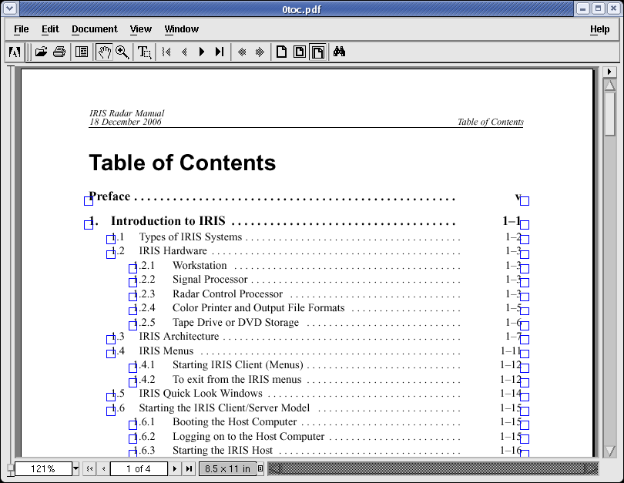
Figure 22: Part of the user manual Table of Contents. The blue boxes represent a link to that specific part of the manual.

Chapters
Introduction to IRIS:

-Types of IRIS Systems
-IRIS Hardware
-IRIS Architecture
-IRIS Menus
-IRIS Quick Look Menus
-Starting the IRIS Client/Server Model

Running IRIS Menus:

-Customizing the List of Servers
-Connecting and Disconnecting Servers
-Moving Among the IRIS Menus
-IRIS Menu Conventions
-The Tools Pull-Down
-Help and the Manuals Menu

Using IRISnet:

-Starting IRISnet
-Interpreting the IRISnet Status
-Lanuching Applications from IRISnet
-IRISnet Drawing Tools
-IRISnet Options -> Config

Radar Status Menu:
-Radar Status Menu
-Running IRIS from the Radar Status Menu
-Mode Switching in IRIS
-Switching IRIS Configurations Automatically

Handling Errors:

-IRIS Message Popup
-Message List Menu
-Fixing Common Problems

Configuring Radar TASKS:

-TASK Configuration Menu
-Obtaining High Quality Data
-Exec Tasks

Scheduling Radar TASKS:

-Task Scheduler
-Adding, Editing, and Removing TASKS in a Schedule
-Running and Stopping a TASK
-Scheduling Automatic TASKS
-Scheduling and Running Manual Scans
-Passive IRIS

Products and Displays at IRIS/Radar:

-Configuring Products
-Scheduling Products
-Quick Look Window to View Products

Appendices
Glossary of Terms and Abbreviations:

-Glossary of common terms used in IRIS
-IRIS Month Abbreviations
-IRIS Data Parameter Abbreviations: Standard Systems
-IRIS Data Parameter Abbreviations: Polarization Systems

Task Configuration:

-Summary of Configuration Examples
-Setting Up the Weather MONITOR Mode

Passive IRIS Features

-Overview
-Passive IRIS Configuration in setup
-TASK Configuration, Scheduling and Synchronization
-TS Playback using tsarchive
-Testing Passive IRIS

Index
The index is used if to ease of access to the important key terms that are in the manual text.

Figures and Tables
Figures and tables of IRIS configurations, menus; Products, and many other features are listed in these sections.

Updated Manuals
The user manuals in IRIS are from December 2006. Updated user manuals and further information regarding IRIS can be accessed using Vaisala’s IRIS Documents page at

http://www.vaisala.com/en/hydrology/offering/weatherradars/Pages/IRIS.aspx

Acknowledgements
Special thanks to the following people who have contributed and updated this manual on the date specified.

11 April 2005 - Manual originally created by Matt Solum, Adam Chambers, Dave Brown, Mikayla Taffe, Kris Lien, Brad Waller, Troy Warner, Nicole Peterson, and Ben Collin for Radar Meteorology class (AtSc 441 taught by Paul Kucera.)

20 May 2009 – Manual updated by AtSc 441 class by professor Matt Gilmore (section 1), Gokhan Sever (Quick Reference and 2–3.2, 6–7), Jason Naylor (3.3–3.5.9), Amanda Homann (3.5.10–3.7), David Keith (3.8–4.1.10), and Randy Johnson (4.1.10–5).

July 2011 – Manual updated and reorganized by Chris Theisen.

